IN MEMORY OF
RICHARD SHIELDS
NT POET AND ACTIVIST
Born 1942 – Died 1st July 2012 UK

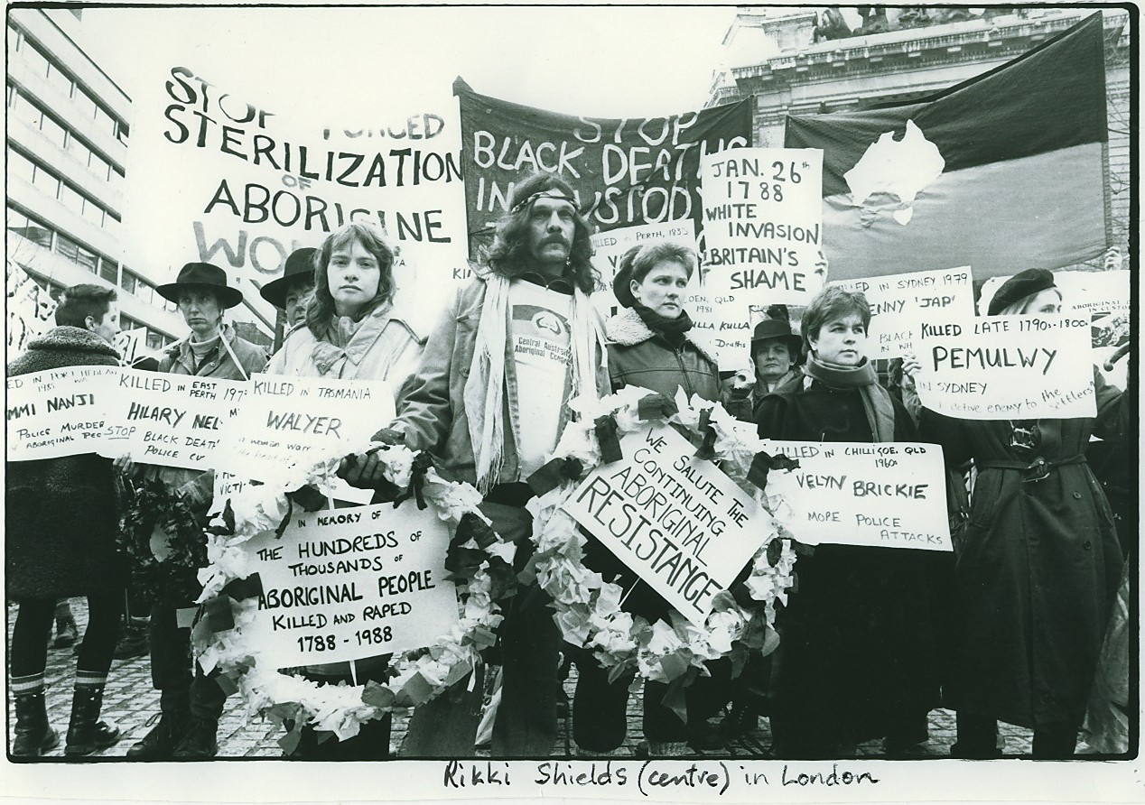
Rikki Shields, London 1988

